Game Design Document

Fill up the following document

1. Write the title of your project.

The Mouse and the snake

1. What is the goal of the game?

To make the snake to reach the mouse

1. Write a brief story of your game.

The mouse is old friend of snake and the snake lost connection with him

and now he is look for his old friend.

1. Which are the playing characters of this game?

* Playing characters are the ones who respond to the user based on the input from the user.
* Cars, monkeys, dinos, wizards, etc., are the playing characters in the game.

|  |  |  |
| --- | --- | --- |
| Number | Character Name | What can this character do? |
| 1 | snake | can move around |
| 2 |  |  |
| 3 |  |  |
| 4 |  |  |
| 5 |  |  |
| 6 |  |  |
| 7 |  |  |
| 8 |  |  |

1. Which are the Non-Playing Characters of this game?

* Non-Playing characters are the ones that don't have an action or behavior when the user interacts with the game.
* Hurdles, stones, bananas, coins, etc., are non-playing characters in the game.

|  |  |  |
| --- | --- | --- |
| Number | Character Name | What can this character do? |
| 1 | mouse | fixed and end of game |
| 2 | wall | if the snake touches the wall the game will start again from beginning |
| 3 |  |  |
| 4 |  |  |
| 5 |  |  |
| 6 |  |  |
| 7 |  |  |
| 8 |  |  |

Draw your imagination of this game. What does this game look like?

* Draw the game either on your computer or on paper.
* Add images of the game scenes to show each of the playing and non-playing characters at least once.

I couldn’t add any animation sorry!!!

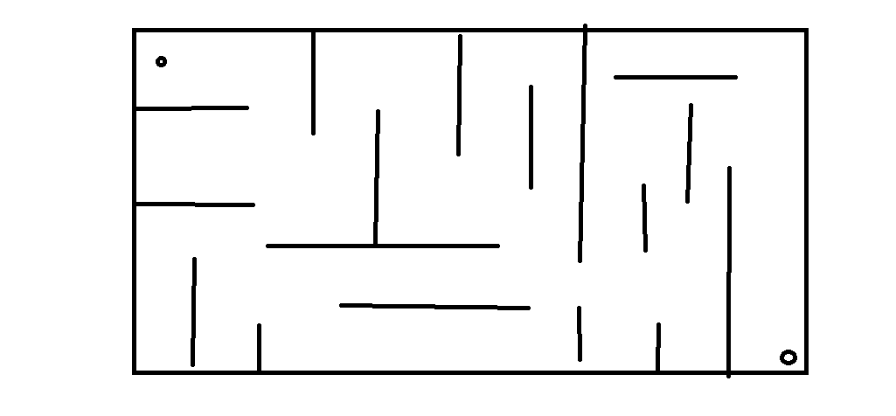

How do you plan to make your game engaging?

Adding more obstacles with different featues